**Aaron Williams**

**Assignment 2**

**30 May 2017**

**Problem 1:**

Build a number-guessing game that uses input validation (isdigit() function) to verify that the user has entered a digit and not a nondigit (letter). Store a random number between 1 and 10 into a variable each time the program is run. Prompt the user to guess a number between 1 and 10 and alert the user if he was correct or not.

Output:

-Correct Guess:

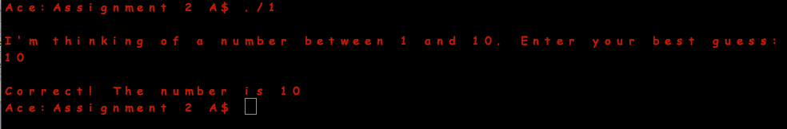

-Incorrect Guess:

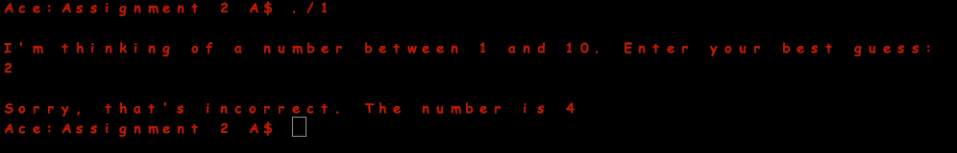

-Invalid Input:

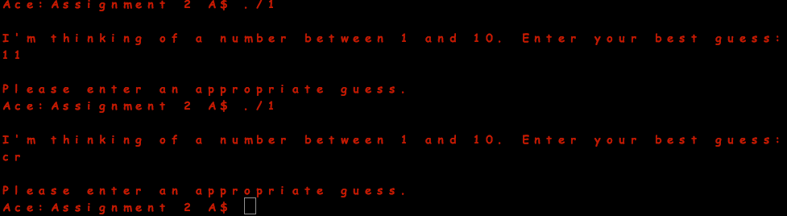

**Problem 2:**

Create a counting program that counts backward from 100 to 1 in increments of 10.

Output:

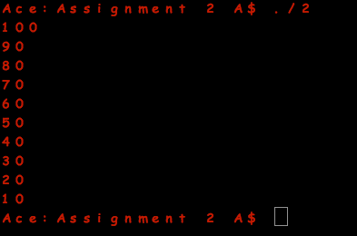

*Note: The final value is 10 and not 1 as specified in the problem because the next increment of 10 would equal 0.

**Problem 3:**

Create a counting program that prompts the user for three inputs (shown next) that determine how and what to count. Store the user’s answers in variables. Use the acquired data to build your counting program with a for loop and display the results to the user:

-Beginning number to start counting from

-Ending number to stop counting at

-Increment number

Output:

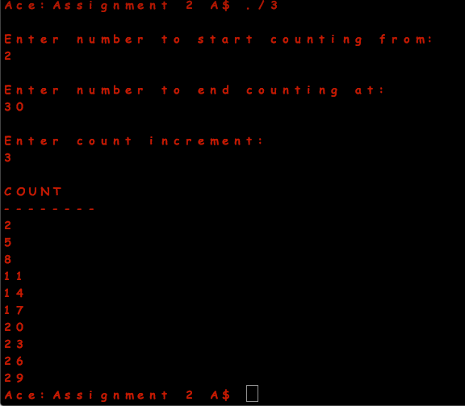

**Problem 4:**

Write a function prototype for the following components:

-A function that divides two numbers and returns the remainder.

-A function that finds the larger of two numbers and returns the result.

-A function that prints an ATM menu-it receives no parameters and returns no value.

Output:

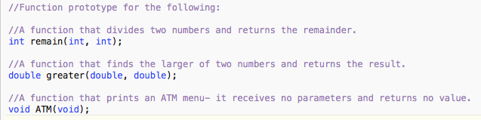

*Note: There is no output because the presented prototypes are not yet defined.

**Problem 5:**

Build the function definitions for each preceding function prototype. Call each of the three functions in the main function.

Output:

